Demonstrating Mantis/400

Demonstrating Mantis/400 1
Introduction 1
Pre-Demo Requirements 1
PHP Changes with Zend Studio for Eclipse (ZSE) 2
Changes to i5 with Lmi 4
Promote everything with LMe 4
Conclusion 5

Introduction
- Mantis/400 is an open source, PHP-driven help desk application.
- It uses DB2 to store all of its data in the form of SQL tables and views.
- The application was written and is hosted by the Curbstone ISV.
- Down and support are here: http://mantis400.com/
- LMe:
  - The web interface (PHP, ini, doc, gif, etc.) is managed by LMe application PHP\Mantis\Base.
  - The release is configured to automatically deploy to the ALDONM00 IFS directory via profile Zend_ PHP_IFS
  - The actual target on ALDONM00 is here: root\www\zendcode\htdocs\mantis400
- LMi
  - The SQL DB2 database is managed by LMi application PHP\Mantis\Base
  - The release promotes all changes to library MANTIS on ALDONM00
  - No deployment is necessary here.

Pre-Demo Requirements
- You must have Zend Studio for Eclipse loaded on your desktop
  - If you do not have it, follow steps 2 and 3 of the “Getting Started with Zend PHP and Aldon LM” document
  - It is located at \\Nemo\sales engineering\Knowledge_Lead\PHP
- Make sure you can access the Mantis application
  - http://aldonm00.hq.aldon.com:89/mantis400/login_page.php
  - If the page does not start, see the instructions in the “Start Up Zend” document at \\Nemo\sales engineering\Knowledge_Lead\PHP
- Create yourself a profile
  - Log in as administrator root
  - Click on Manage, then Manage Users, then Create New Account
  - Enter user name, real name and your working Aldon email address (important).
  - Access level should be Manager
  - Enabled should be checked
  - Protected should NOT be checked (this locks you out).
  - Click on Create User
  - I believe this sends an email to the email address which gives you further instructions on activating your new account.
- Populating Zend Studio Eclipse workspace from the Repository:
  - Once you have ZSE on your laptop and the Aldon Plug-in plugged in, you’ll need to download the Mantis project from LMe into your personal workspace.
  - Open up your ZSE and go to the Resource perspective.
  - If you are not already seeing the “Aldon Repository” view, use Window, Show View, Other then Aldon Lifecycle Manager and Aldon LM Repositories.
  - Explode the list and drill down to the Mantis project.
  - Select “Add to Workspace” to add it to the default workspace.
  - THIS IS A LONG STEP. Maybe 30 – 60 minutes.
  - This puts the project on your screen and connects you to the repository in LMe.
  - RC on the project header in eclipse and select Team, Force Get Latest.
  - You should see the “< >” symbols disappear from before the project name.
  - NOTE: this will also add the path to this IDE project in your LMe Developer Environment, so if you checkout directly from LMe it will work just the same.
- To make the environment look more realistic, check out one or two items that show up on the first screen and leave them permanently checked out under your name. You can take any item EXCEPT “login_page.php”. This is the one that we will actually be changing and promoting to show off the effects of our change in our live web site!

PHP Changes with Zend Studio for Eclipse (ZSE)
- Point your browser to the Mantis application web site mentioned above. (I have this page bookmarked for easy access).
- DO NOT CLOSE THE BROWSER. It will be more effective later if you leave it open!
- Explain that this is an open source example created by Curbstone to demonstrate how PHP can interact with the IBM i. It can be downloaded from www.mantis400.com
- On the login page, point out the *** Managed by Aldon Lifecycle Manager *** message. We are going to change the color of the text in our demo.
- 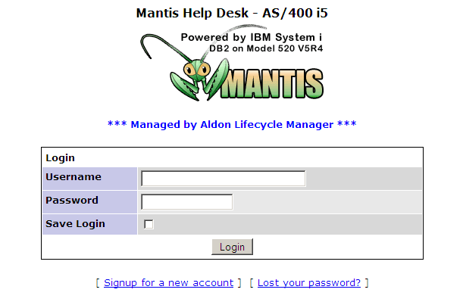
- The master application is served from ALDONM00’s IFS (I have a mapped drive to this location to make getting here quick): \\Qaldonm00\ root\www\zendcode\htdocs\mantis400
- Open LMe and navigate down to PHP/Mantis/Base
- Explain that we loaded the master inventory from the original artifacts that Mantis loaded in the IFS
- Open up Zend Studio for Eclipse (ZSE). Explain that this is a free IDE that you can download from the Zend.com website.
- It is Eclipse 3.3, so we can add the Aldon Eclipse plug in directly to it.
- Show the Zend Navigator project and how it is connected to the LM inventory that we showed above.
- Show how the work of other developers is reflected in the status of each artifact.
  - An item checked out to another developer has the “[ O]” symbols behind the name.
  - An item checked out to multiple developers would have the “[MO]” symbol.
- Scroll down the main directory until you find “login_page.PHP”
- RC on “login_page.php”, select Team, check out.
- Show the decorators, show the messages in the Aldon Status view, show the changes to LM, show the changes to the task in CM (if you linked one), etc.
- DC on the artifact to change it.
- Scroll down to line 60.
- We will be changing the color of the Aldon message line between blue and red. 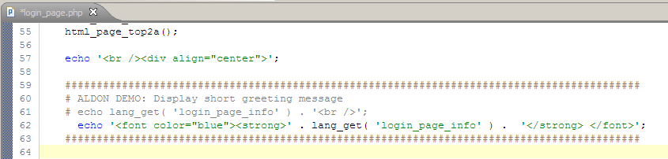
- RC on the artifact, go to “Compare with” then “Latest from Aldon LM”
- Change the Mantis configuration file:
  - Long-time users of Mantis tell us that managing changes to the configuration setting files that drive Mantis are very important.
  - Open up ZSE and navigate down to “config_inc.php”
  - Check it out
  - Change the last changed date at the top of the file.
- RC on the Mantis400 Project header, go to “Team” and “Check in”.
- Switch over to LMe and show that it is now in QA.

Changes to i5 with Lmi
- NOTE:
  - Please only checkout the file listed below. Checking out other files may end up corrupting the database because of some quirks with CPYF and SQL design.
- Change default application to PHP/Mantis/Base
- Check out the very first file IDX_ACCESS
- Make no changes and promote to QA.

Promote everything with LMe
- Navigate to the Collection view and open up the task.
- RC on the task and promote everything.
- Click on the Deployment tab and make sure you are deploying to “Zend_PHP_IFS”.
- Explain that this profile is configured to move this artifact to the IFS directory structure on ALDONM00 that is serving this application:
- 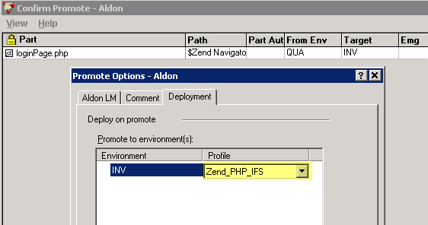

Conclusion
- Show that the inventory status is now a “P”
- Show that the deployment set has completed installation successfully
- Return back to your browser and show the original page, then hit the refresh button and show the change!
- If you wish, open up the IFS directory (I have a Network Location mapped to it for fast access) and show that the file has just changed:
- 